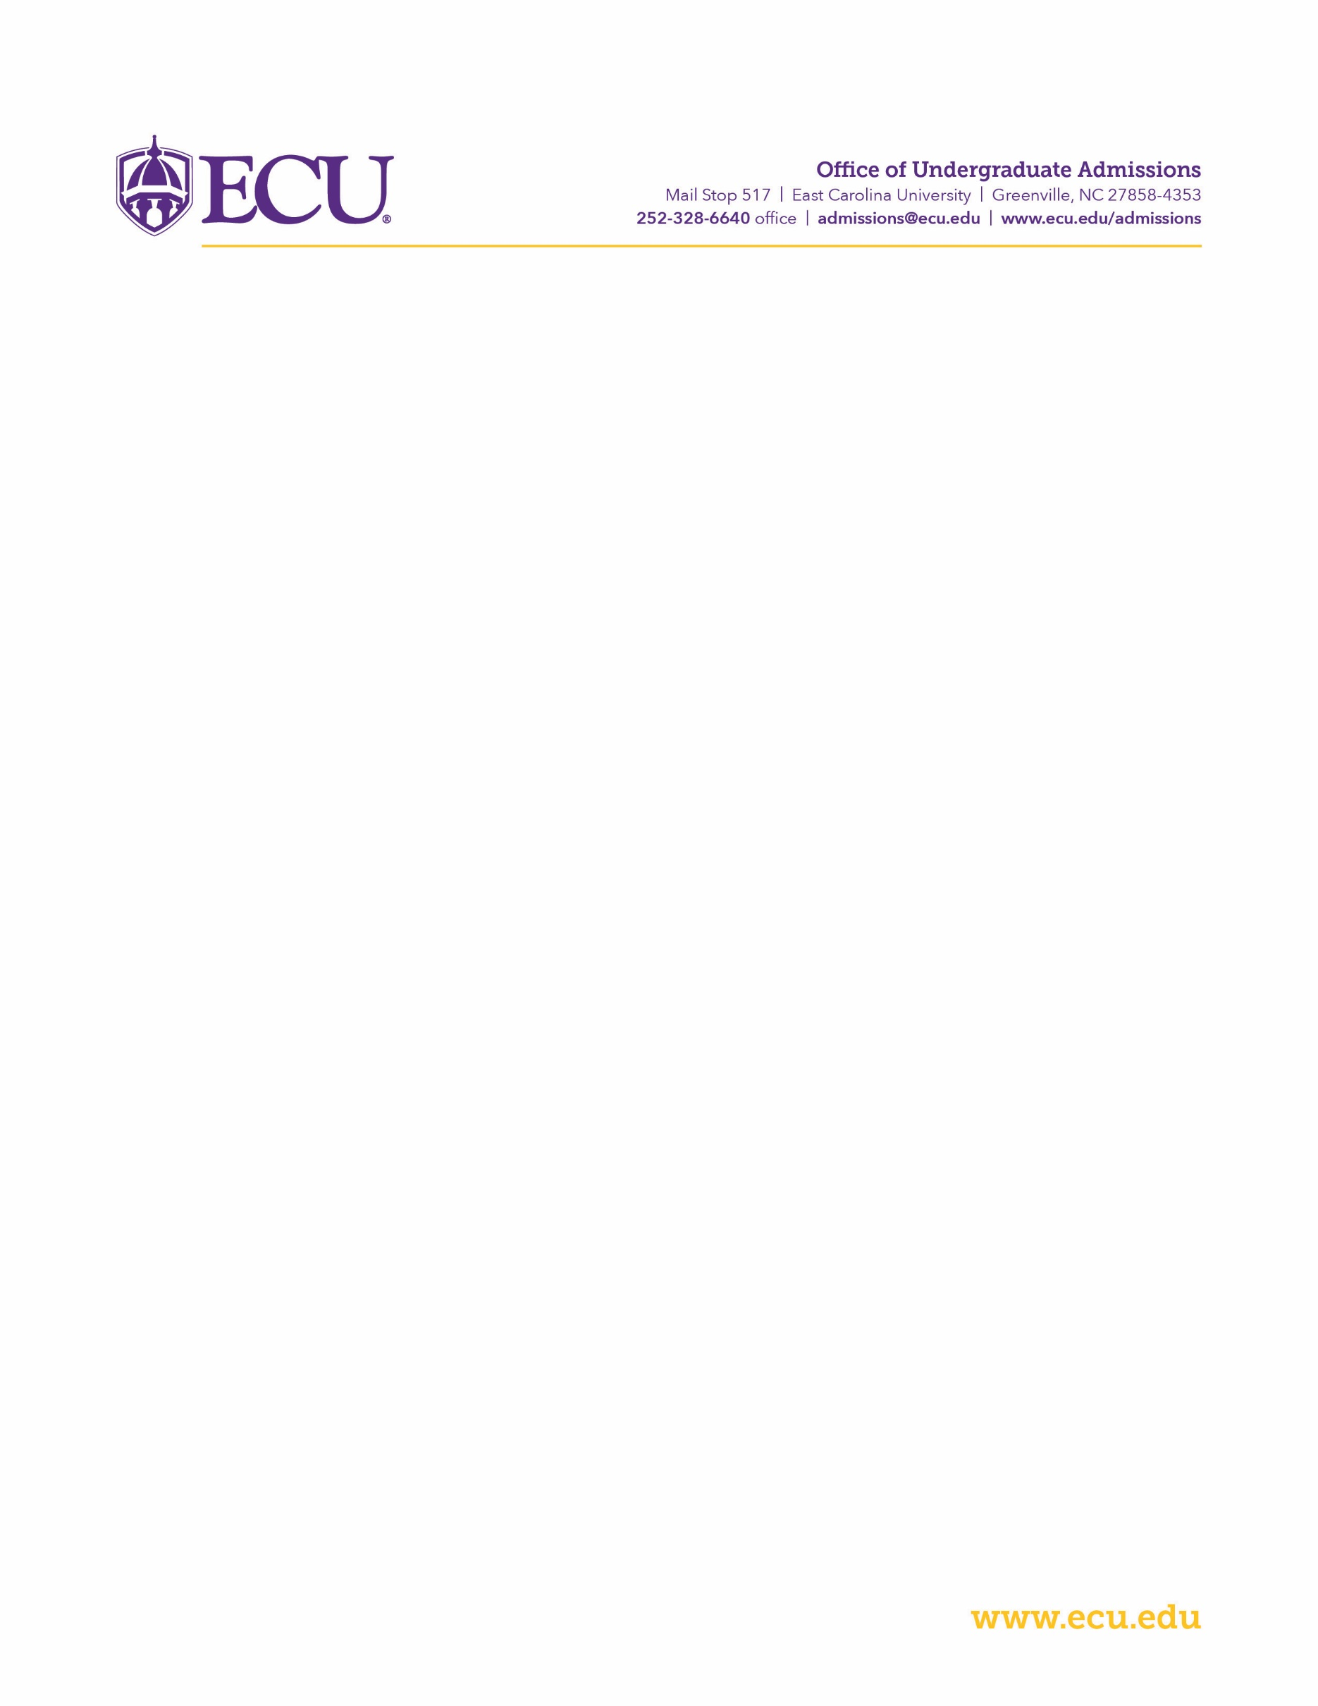
ECU Associate in Applied Science (AAS) Degree Verification Form

Student Name: _______________________________________________
AAS Degree Title: _______________________________________________
Community College: _______________________________________________
Date AAS awarded (or future date): ___________________________________

This form serves to verify that the student above will complete his/her Associate in Applied Science (AAS) degree in ________________________________________________________ by ________________________ as long as he/she successfully completes the courses he/she is currently enrolled in.

_______________________________________________ __________________
Registrar Official’s Name Date

_______________________________________________
Registrar Official’s Signature

Send form to ECU Office of Undergraduate Admissions:
- Email: transfer@ecu.edu; Fax: 252-737-1192

For any questions, contact ECU’s Office of Undergraduate Admissions at transfer@ecu.edu or 252-328-6640.

